**ADBMS Practical**

Practical 2: Subquery-join operations on Relational Schema

**Q1).USING (practical 1)**

**1.** **Count the customers with grades above Newy yorks average.**

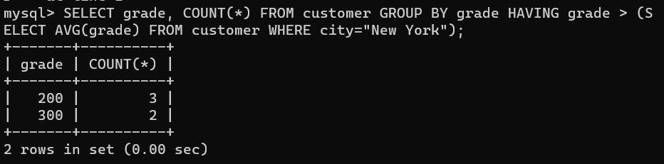

**2. Find the name and numbers of all salesmen who had more than one customer.**

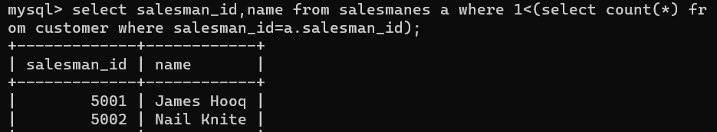

**3.** **List all salesmen and indicate those who have and don’t have customers in their cities(Use UNION operation.)**

**query 3.png**

**Q2).Design ERD for the following schema and execute the following Queries on it:**

**Consider the schema for Movie Database:**

**ACTOR (Act_id, Act_Name, Act_Gender)**

**DIRECTOR (Dir_id, Dir_Name, Dir_Phone)**

**MOVIES (Mov_id, Mov_Title, Mov_Year, Mov_Lang, Dir_id)**

**MOVIE_CAST (Act_id, Mov_id, Role)**

**RATING (Mov_id, Rev_Stars)**

**1.** **List the titles of all movies directed by ‘Hitchcock’**

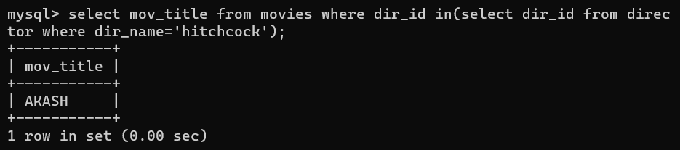

**2.** **Find the movie names where one or more actors acted in two or more movies.**

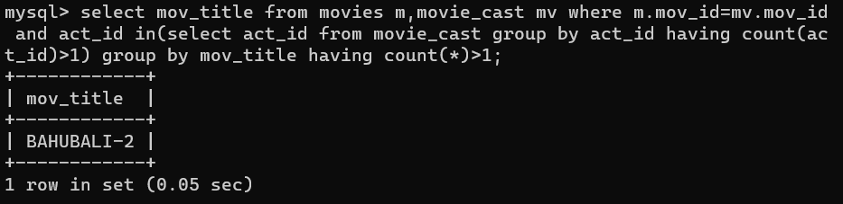

**3.** **List all actors who acted in a movie before 2000 and also in a movie after 2015 (use JOIN operation).**

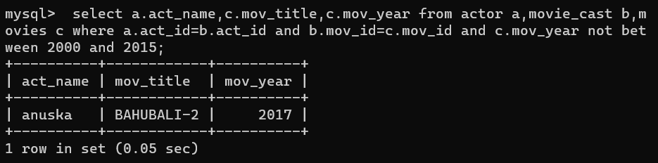

**4.** **Find the title of movies and number of stars for each movie that has at least one rating and find the highest number of stars that movie received. Sort the result by movie title.**

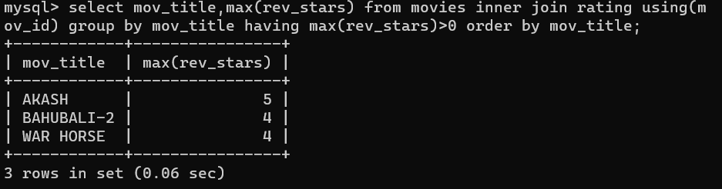

**5.** **Update rating of all movies directed by ‘Steven Spielberg’ to 5.**

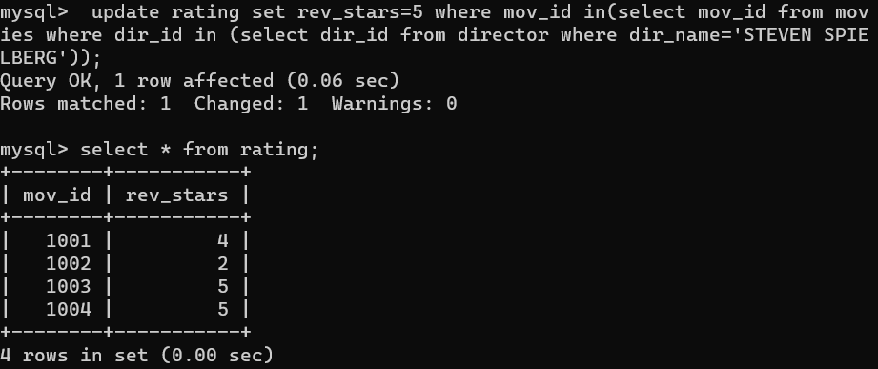

**Q3). Design ERD for the following schema and execute the following Queries on it:**

**1.** **Find the names of students who took only four-credit courses.**

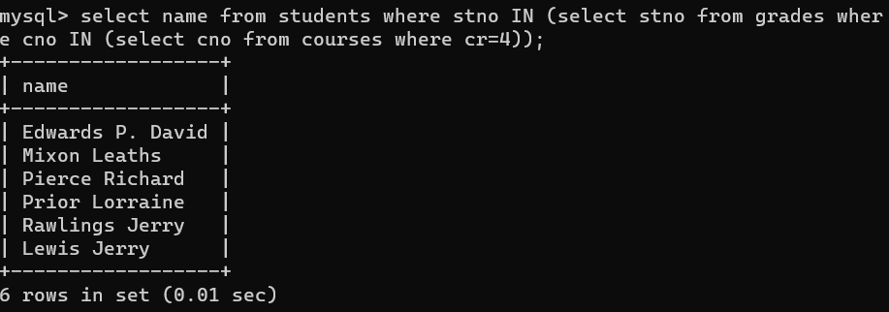

**2.** **Find the names of students who took no four-credit courses.**

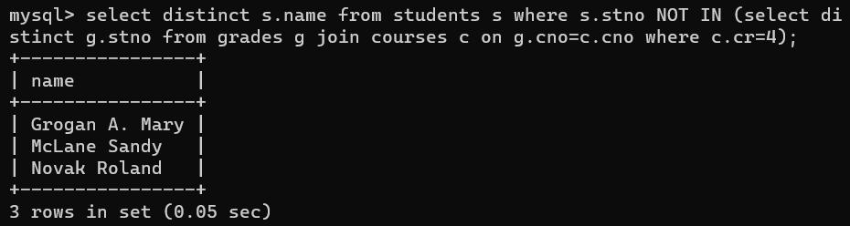

**3.Find the names of students who took cs210 or cs310.**

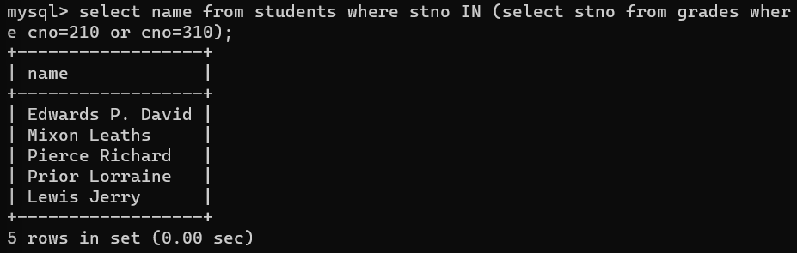

**5.** **Find course numbers for courses that enrol at least two students; solve the same query for courses that enroll at least three students.**

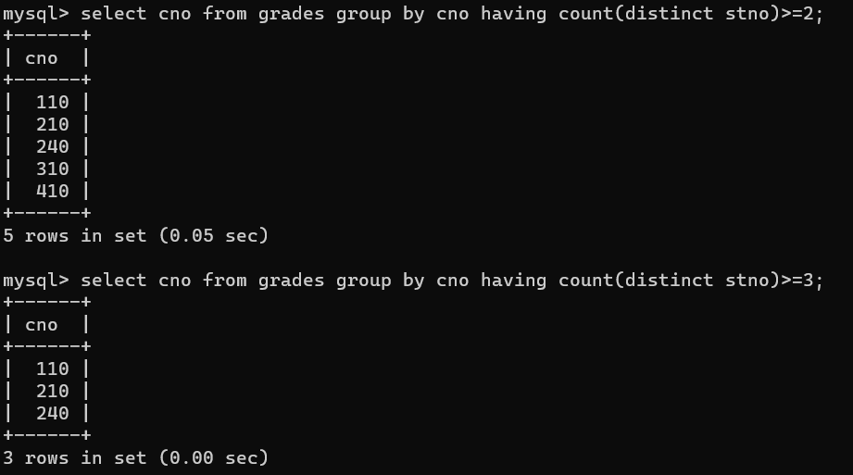

**6.** **Find the names of students who obtained the highest grade in cs210.**

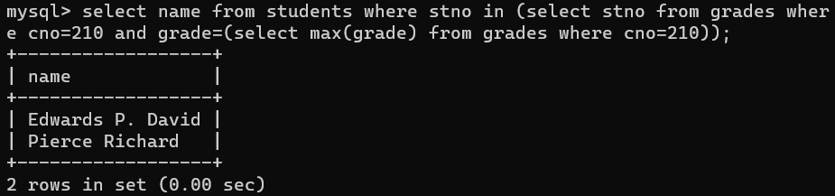

**7.** **Find the names of instructors who teach courses attended by students who took a course with an instructor who is an assistant professor.**

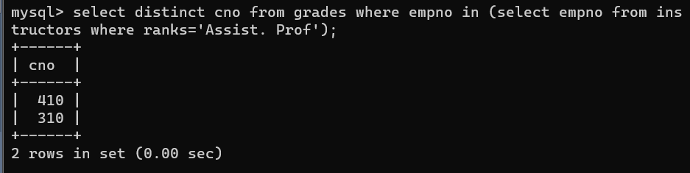

**8.** **Find the lowest grade of a student who took a course during the spring of 2003.**

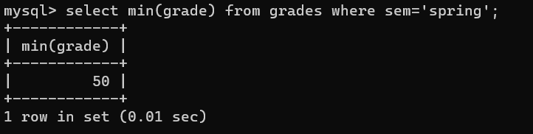

**11. Find the names of students who have failed all their courses (failing is defined as a grade less than 60).**

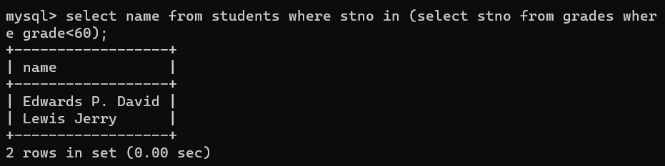

**12. Find the highest grade of a student who never took cs110.**

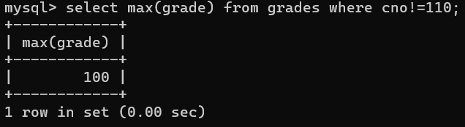

**13. Find the names of students who do not have an advisor.**



**14. Find names of courses taken by students who do not live in Massachusetts (MA).**

